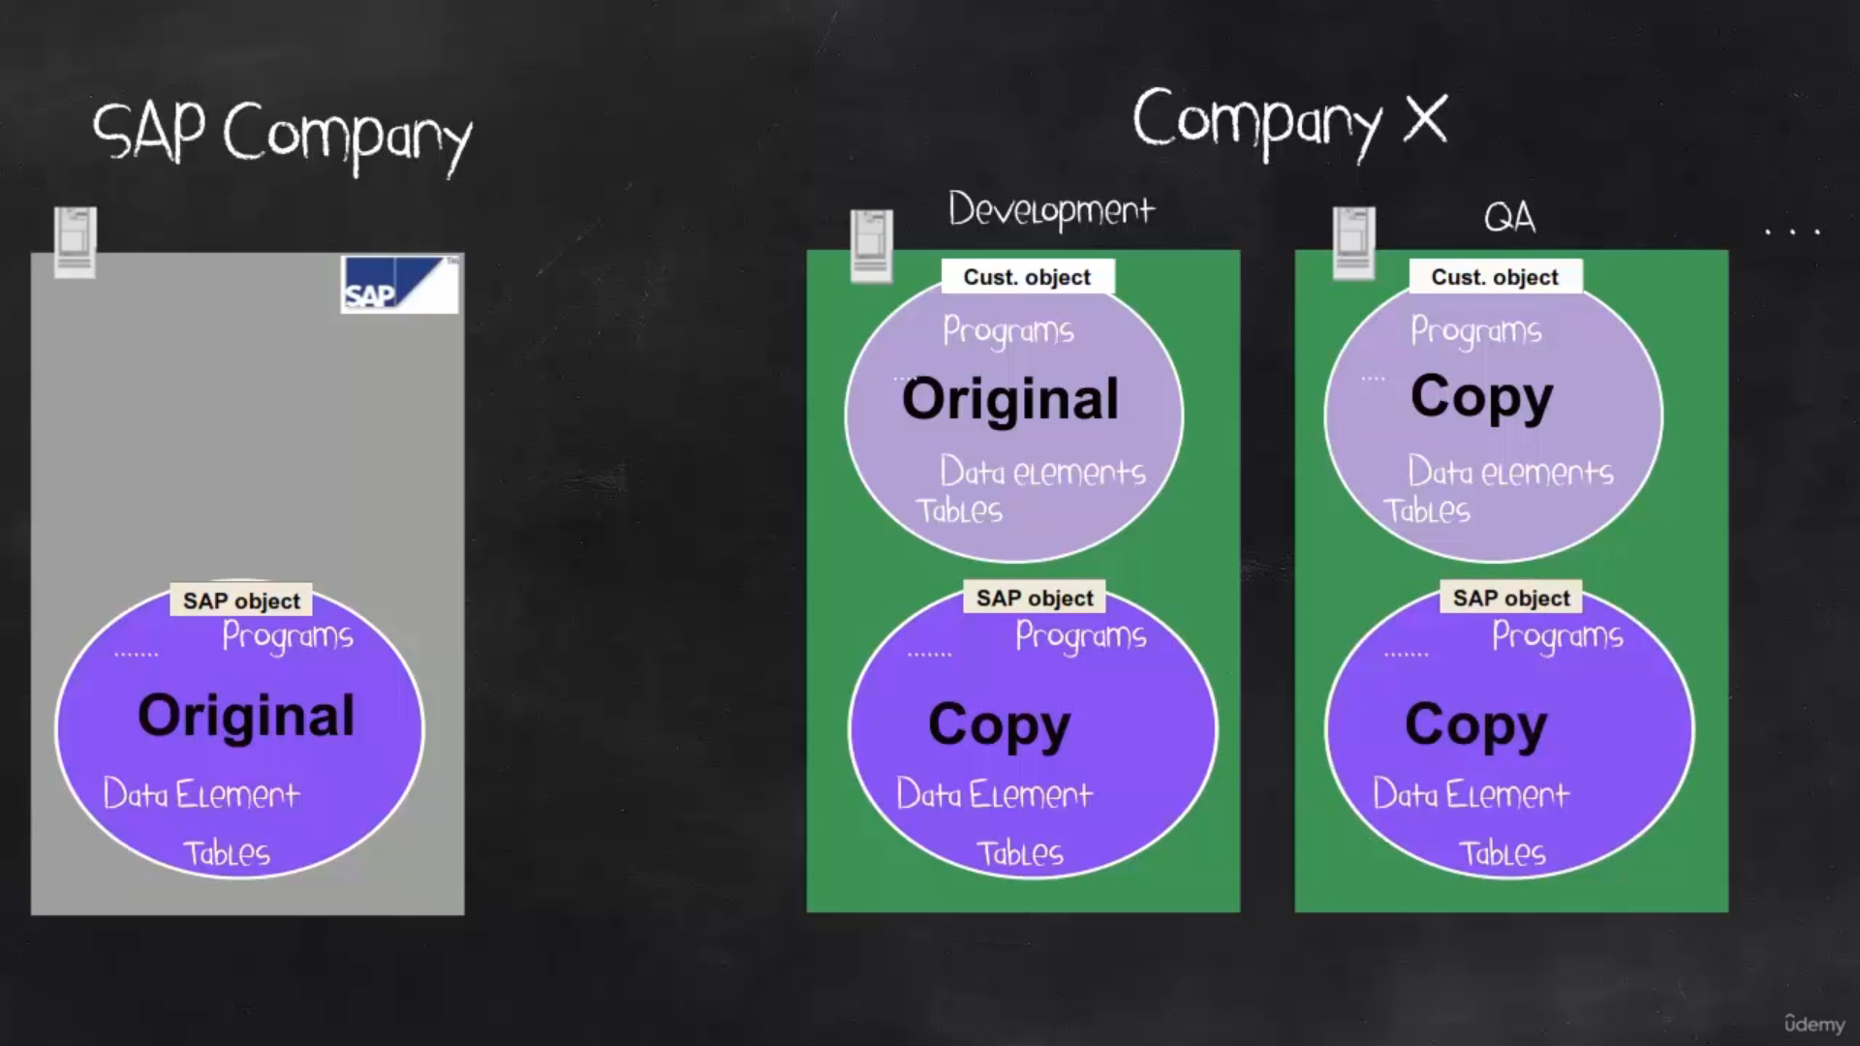

SAP OBJECT IN DEVELOPMENT IS INITIALLY COPIED FROM SAP COMPANY OBJECT

CUSTOMER OBJECT ARE ONLY ORGINAL OBJECTS

WHEN OBJECTS ARE COPIED FROM DEVELOPMENT TO QA A COPY IS MADE

How does actually the S&P enhancement WORK Inside the S&P standard objects, there are calls to customer objects.

When the object that is called is not yet created. So the SFP standard object will call nothing. And it remains a standard. And when the customer object is already created.

So this customer object will add or change the color functionality or the SFP standard object functionally.

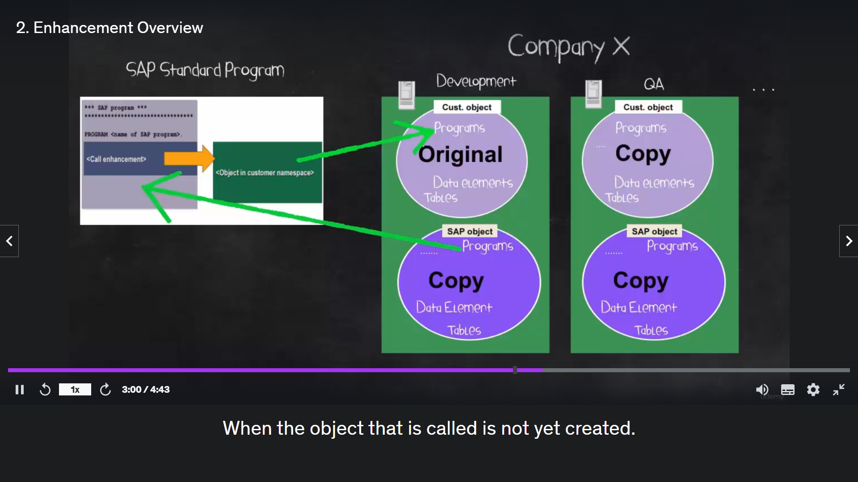

TYPES OF ENHANCEMNETS

